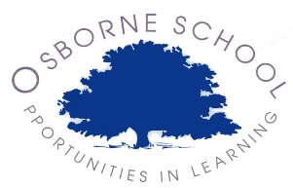

Osborne School –Year 7 Catch up Funding

Year 7 catch up funding is an allocation of additional funding provided to schools to support specific year 7 groups of children who are not going to meet the national achievement thresholds set by the DfE

Due to Osborne school being a special school all of our pupils are behind in their achievement in relation to their mainstream peers

Schools are free to spend the year 7 catch up funding in any way that will support year 7 to increase their achievement and aim to bring them in line with the thresholds set.

The interventions currently used at Osborne are used to ensure pupils have maximum opportunity at year 7 to reach their maximum potential; these are as follows;

**No. Nature of Intervention**

1. Speech and communication
2. Music Therapy
3. Emotional Support
4. Dyslexia Support
5. Math’s Development
6. SLT Oversight of Interventions
7. Reading Development
8. OT- Sensory Support
9. Extra curricular activities and support
10. ICT support
11. Drumming

|  |  |
| --- | --- |
| **Year 7 Catch Up Allocations** | |
| **Financial Year** | **Amount** |
| 2014-2015 | £12,000 |
| 2015-2016 | £9,500 |
| 2016-2017 | £20,000 |
| 2017-2018 | £15,000 |