Dear Respected Sir,
Carry more than 24 years’ experience whilst being committed with international luxury hotels across Middle East, Africa and Europe regions. Currently occupied at Sheraton Essen Hotel, Germany.
- Beforehand, enjoyed working as leading pre-opening team member at Four Points by Sheraton, Riyadh, Saudi Arabia. Designed, developed and implemented standard operating procedures, technical documentation and brand specifications. Re-established entire IT infrastructure through comprehensive project.
- Bhutto Women University, Peshawar, Pakistan; associated as official IT Consultant to direct and guide the wide ranging running IT projects over half a million euros for 3 huge campuses in the city.
- Luxury 5* Corinthia Hotels International property in Tripoli, Libya was exciting challenge as well. Managed and led a project to re-furbish the entire IT property infrastructure using latest air blown fiber FTTX technology (fiber to the rooms) with over one million euro project.
- Hyatt Regency Hotel & Towers, Makkah Saudi Arabia; Luckily, several years of constant working affiliation provided the freedom to execute several projects in order to maintain the property with latest technology trends.
- Grand Continental Hotel, Abu Dhabi, UAE; profoundly occupied on pre-opening with this unique 23rd story building. IT Infrastructure constructed from scratch mounting the latest PMS hotel system at the time, i.e. Opera, MC, MFF, Micros 9700 apart from supervising complete network infrastructure.
IT Academy certification from Starwood and Marriott International: Barcelona Spain December 2013, Istanbul Turkey November 2015, Vienna Austria November 2016 and Amsterdam Holland January 2018.
Participated as key management member in conventions taking place in Germany, France and Switzerland; organized by Hyatt International to converse the IT future approach on corporate level in Year 2000.
"Managing IT Projects" certification in year 2001from ESI International London, affiliated with George Washington University, United Kingdom.
Have an extensive knowledge with industry's standard systems i.e. Windows Server, Workstation, network infrastructure, WAN/LAN, FTTX, structured cabling networks, Data and voice IP communication, Wi-Fi GPNS standards, ORS, Sales Force Automation, OCIS, OXI, IPS, SYNXIS, domain controller, Active Directory, firewall & VPN applications. Yet, counting the most prominent are OPERA on Data Guard, cluster and cloud environment, MFF SUN, SAP and Peoplesoft System, Material Control, Micros-9700/3700 POS Simphony, Interfaces, Vingcard VisiOnline Keyless door lock system, Digital Signage and Exchange Server.
As whole, I am able to initiate, execute and manage multi-disciplinary projects. Develop and execute policies, procedures, operational manuals, plans and strategies for complex IT projects including the ERP and Business Intelligence Projects, which may involve large end-user participation and negotiation. My critical role is to ensure that the technical products, solutions, product costs and strategies, positively reflect on the success of the projects. I act as a single point of contact for all the aspects of projects.
Hence, given a chance, I shall give my best shot to maintain your standard upon your satisfaction.
I may be contacted on my mobile# +49 151 55021629 or through my e-mail naseer@hotmail.com at any time.
Thank you for your favorable reply.
Respectfully yours,

Naseer Qureshi
Walter-Hohmann Str.4
Essen 45128, GERMANY
NASEER A. QURESHI
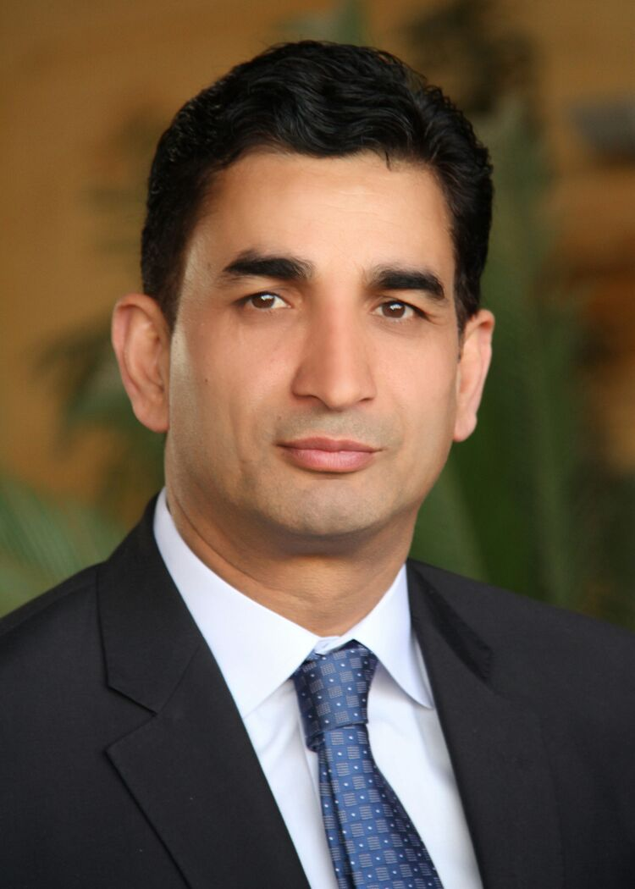
Walter-Hohmann Str.4, Essen 45128, GERMANY
Mobile: +4915155021629

Email : naseer@hotmail.com

http://sa.linkedin.com/in/naseerqureshi

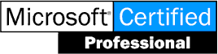
SUMMARY

Profile: Male, 48, Married, Pakistan National
Work Eligibility European Residence with work permit.

Current Location: Essen, GERMANY
Current Position: IT Manager
Company: Sheraton Essen Hotel, Marriott International
Total Experience More than 24 Years as IT Manager / Director

OBJECTIVE

To be a leader in providing quality Hospitality services on a competitive basis to the corporate entities and individuals in our services area, to generate sufficient profits to meet our services growth standard. Strong approach on the staff duties and operations in order to delegate responsibilities and efficiently supervise the staffs to appreciates the contributions and skill of all employees. Maintain high level of professionalism in accordance with the company’s preset standards.

CORE COMPETENCIES

- Consulting & advisory, Client Management, Consulting partners, Corporate Development, Business Negotiations, Enterprise and IT Strategy.
- Technology and business visionary with executives as well as hands-on technical experience in opening and managing multi-million dollar enterprises. Strong record of accomplishment of successes in creating robust IT architectures and infrastructures. Proven ability in leveraging technology to support the business; while managing costs and risks.
- Distinction of successful business process re-structuring, implementation of business solutions in organizations within preset budgets and deadlines.
- Insightful knowledge of business process analysis and design, re-engineering, process rationalization, cost control, capacity planning, performance measurement and quality.
- Contributes to the morale and team spirit of the hotel by maintaining effective relationships with colleagues.
- Is polite and professional in any situation where the image or reputation of the company is represented.

KEY RESPONSIBILITIES

- Works with property management and Regional leadership to participate in the acquisition of technology services for guests through an understanding of the property specific business.
- Provides strategic leadership for initiatives and projects, and coordinates with regional leadership to enhance services.
- Performs assessments of needs ensuring compliance with budget, standards.
- Determines priorities, schedules, plans and necessary resources to ensure completion of property projects on schedule and according to specification.
- Ensures property's technology assets are secure and maintained in accordance with corporate policies and standards.
- Management and continuous development of the IT Teams and peers.
- Ensures compliance to technology-related vendor contracts.
- Foresees, identifies and resolves system(s)' performance problems
- Certifies software applications for use at property
- Provides timely, accurate, and detailed status reports as requested
- Evaluates and makes recommendations regarding technology/asset life cycles. Ensures that property is properly equipped in terms of PCs, hardware, servers, etc.
- Creates and ensures implementation of disaster recovery and business continuity plans as they relate to technology.
- Ensures availability of current documentation for cabling, network diagrams, and applications exist.
- Reviews networks' performance and performs design/re-design as needed to meet property needs.
- Ensures periodic inventories of applications and hardware are conducted.
- Forecasting and Complying with Financial Parameters

Contd………..P/2
-: 2 :-

- Analyzes, communicates and implements property strategy to drive technology revenue and contribute to property's overall business success.
- Responsible for monitoring and controlling all technology-impacted revenues and expenses generated by the property including, but not limited to: telecommunications, HSIA, business center technologies and A/V
- Ensures that property management has realistically budgeted CAPEX and department operating budgets based on anticipated IT projects and property support/needs requirements.
- Ensures that property management has adequately addressed technology needs in short- and long-term planning.
- Reviews vendor proposals and selects appropriate vendor for technologies/hardware.
- Responsibility for the stability and the implementation of tactical measures and optimization of the IT infrastructure.
- IT project management and management of the team to build the IT infrastructure to pre-opening/new locations.
- IT process optimization and support of IT innovations.
- Ensuring on call support, problem solving, Trainings, Checklists, Operation, Technology Standards, Communication, Disaster recovery implementation, back-up procedures, security and control structures.
PROFESSIONAL EXPERIENCE


July 2015 – Present

SHERATON ESSEN HOTEL, Essen, GERMANY http://www.sheratonessen.com

Information Technology Manager
Manage IT department for 206 rooms business hotel
Accomplishments:
- Implemented Dell VMware Server environment replacing old servers.
- Re-furbished the entire admin/guest IT network infrastructure,
- New switches Installed with appropriate VLAN configuration, as required.
- Server room renovation with standard environment. Cabling tags implemented.
- VEEAM Enterprise Backup for disks and tapes solution implemented.
- Latest Vingcard VisiOnline keyless/mobile access project initiated and completed.
- LAN migration from Starwood to Marriott network standard environment
- WiFi GPNS standard installation and GRE solution with new TVs and infrastructure.
- HSIA gateway with conference tools implemented besides multiple package plans introduced.

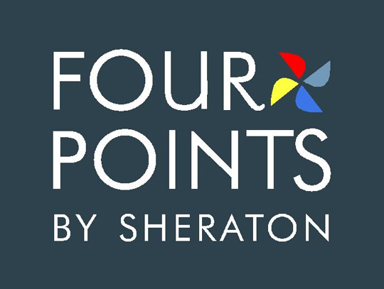
November 2012 – December 2014

FOUR POINTS BY SHERATON, Riyadh, Saudi Arabia http://www.fourpointsriyadhkhaldia.com

Director of Information Technology

Managed IT Department for 376 rooms hotel with three residential Towers of around 500 apartments owned by the owning company.
Accomplishments:
- Servers’ installations e.g. PMS Opera, SUN, POS, MC, HR, Interfaces, key card, WSUS, office automation, file and print Servers. Firewalls and IPS routers for WAN Connectivity. AV installation on centrally controlled environment.
- Re-furbished Guest Wi-Fi with additional APs and expended network infrastructure with -65 DB signal strength.
- Constructed Server room with standard environment by raising floor, FM 200, Water detectors, metal door, cable trays installation and cable management.
- Backup Exec Symantec solution installation and implementation completed.


October 2011 – October 2012

BHUTTO WOMEN UNIVERSITY, Peshawar, Pakistan http://www.sbbwu.edu.pk

IT Consultant

Function is to lead and guide the operation of the IT Department at the university throughout Pakistan; Lead the IT projects for new campuses under construction within the city. Primary duties include provision of IT infrastructure services, including new computer systems, Software integrations, telephone and other related systems. Further, propose new technologies to the management.

Contd………..P/3
-: 3 :-
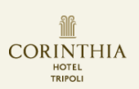
October 2008 – March 2011

CORINTHIA BAB AFRICA HOTEL, Tripoli, Libya http://www.corinthia.com

Information Technology Manager

Managed IT department with 3 peers for luxury 300 rooms hotel in capital of Libya.
Accomplishments:
Design, installation and Commissioning of the UCI with air blown Fiber Optic Technology based on FTTX. The project covered 300 Rooms, Shops and admin network. Project objectives are:
- Cabling Network for offices, Main data communication room, Data and Voice Communication systems based on IP, WiFi Infrastructure with 380 wireless CPE units to cover the hotel rooms and various areas, SMATV, CATV, IPTV, CCTV Control and EPOS Network.
- SYNXIS - Central Reservations systems TWO WAY INTERFACE to distribute hotel product on the GDS (Amadeus, Sabre, Apollo...), online Travel Agencies (Expedia, Venere..) and internet distribution systems.
- Installation of ORS (Opera Reservation System) for a Central reservations Office, Loyalty Program, Sales Force Automation, Business Intelligence.
- OCIS -... the database that will contain all stay / behavioral information on our customers, and OXI-Opera Exchange Interface Installation.


January 1999 – October 2008

HYATT REGENCY HOTEL & TOWERS, Makkah Saudi Arabia http://www.hyatt.com

Information Technology Manager

Managed IT department for 3 towers consists of 200 rooms and 120 apartments.
Accomplishments: November 2005
- Installation and implementation for OPERA, SUN, Micros 9700 POS, Material Control and Exchange Server 2003.
- Constructed new server room environment, and implementation new 6 Servers, 72 workstations and interfaces.
- Shifted the focal system from the UNIX platform running CLS to Windows environment without freezing the running operation. Nevertheless, the successful migration of the data and files done adequately.
- Upgrade of entire backbone network structure with the Fiber Optic and expanded network infrastructure.
Accomplishments: October 2000
- Successful migration of all the property data, files, IP addresses from Novell to Windows NT 4.0 Server environment.
- Conversion of Network from BNC/RS232 to latest RJ45 TCP/IP cabling standard.
- Successful Integration of SCO UNIX with Windows NT through TCP/IP setup and emulation program.
- Successful implementation of built-in network HP printers over TCP/IP network.

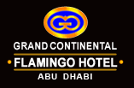
December 1996 – December 1998:

GRAND CONTINENTAL FLAMINGO HOTEL, Abu Dhabi, U.A.E. http://www.gcfh.ae

Information Systems Manager

Joined on pre-opening and Complete IT infrastructure and IT Projects initiated from scratch.
Accomplishments:
- Server Room consructions, designed, implemented and executed the entire project.
- Actively participate and coordinate with General Manager to make decisions for the PMS, POS, BOH, Payroll, Inventory program and other software for the hotel.
- Plan the network structure independently to lay the cables layout within all the departments of the hotel.
- Data definitions for PMS/POS/BOH, Installation issues of NT & UNIX Servers, network linkages among all the PCs and printers using TCP/IP technique were some of the tasks that stood completed successfully.


April 1996 – December 1996:

AL-FALAK ELECTRONIC EQUIPMENT & SUPPLIES CO. Al-Khobar, Saudi Arabia

Administrator

Al-Falak is a leading Gulf wide IT and communications solution provider. Its service offerings include IT consultancy, network solutions, computer hardware, computer supplies & accessories, application software, and work force outsourcing.

Aapril 1994 – February 1996:

THE OASIS RESIDENTIAL RESORTS, Al-Khobar, Saudi Arabia (pre-opening exp.)

Office Manager
Join on pre-opening. The luxurious 273 unique Villas comprising luxury Hotels, Restaurants and Recreation facilities within the compound area, are a Division of Saad Group. Hired as Office Manager on pre-opening.

Contd…..P/4
-: 4 :-

EDUCATIONAL TRACE:

February 2010 Managing IT Projects - Certification with 88% Marks from ESI International, London, UK
Nov 05-Mar 06 Certificates from Micros-Fidelio - Saudico Electronic Systems, Riyadh, KSA
Courses attended (Advance Level): OPERA, MF Financials, MC, Micros 9700, Vision XL.
May 2001 Microsoft Certified Professional – from Microsoft
Recognized as Microsoft Certified Professional by Microsoft.
February 1993 Graduation from Punjab University, Pakistan – GPA 2nd Grade
Nov 92-Nov 93 Diploma in Computer Maintenance – from Petroman Training Institute, Islamabad, Pakistan.
Subject Studied: Programming in Assembly Language, Fundamentals of Electrical and Electronics, Digital Electronics, Digital Computer Basis, Computer Systems Maintenance, Peripheral Maintenance, Interfacing with Computers, Computer Architecture and Organization, Project work.
Aug 90-Aug 91 Diploma in Computer Applications – from Petroman Training Institute, Islamabad, Pakistan.
Subject Studied: Computer Concept & Architecture, COBOL Language, Lotus, P.O. Accounting, DOS, UNIX, C-Language, System Analysis & Design, Pascal Language, Project work.
July 1996 Certificates in Computer Applications – Al-Khaleej (div. of New Horizons USA), Al-Khobar, KSA
Courses Studied: MS Windows, Excel, Word, PowerPoint, Access and DOS etc.
PROFESSIONAL COURSES ARRANGED BY HYATT INTERNATIONAL

Location: at HYATT REGENCY HOTEL, Mainz, GERMANY
The Challenge | Vision, Mission, Goals, Tactics | Industry Related Technology Update | Technology Master Plan Update | Spirit Training | Revenue Management | HYadvantage Updates | Data Warehousing / Cognos | Time Management.

LANGUAGES KNOWN

Fluent English, Urdu and Punjabi, and plus Soft Arabic, Soft Deutsch (german)
Full command over English (Written & Spoken), plus able to handle Correspondence independently.
RECOGNITION LETTERS:

Certificates awarded by Starwood Hotels & Resorts worldwide
- IT Academy Certificates for 2013, 2015, 2016 and 2018
- PCI Compliance Training – November 17th 2013
- 2013 Worldwide Code of Business Conduct and Ethics Recertification – November 23rd, 2013
- GEI Portal Training – July 17th, 2013
- My Role as a DC Administrator – May 3rd, 2013
- Service Culture Training – April 22nd, 2013
- Behavioral Interviewing Certification – April, 2013
- Management Skills Part I & II
- Management Excellence Award
- Time Management
- An Excellent Management Performance Appraisal

REFERENCES:
Mr. Reuben Mifsud – ClusterGeneral Manager (ex Director HR Corinthia Hotel, Tripoli)
Meydan Hotels & Hospitality, Dubai, UAE
Mobile: +971565052251 Tel: +97143813122
Email: reuben.mifsud@meydanhotels.com - reuben.mifsud@corinthia.com;
Mr. John O’Brien – ex GM for Corinthia Bab Africa Hotel, Tripoli, Libya
Australia, Mobile: +61403205611, Email: johnicon19@hotmail.com
Mr. Juan Uribe– Cluster General Manager (ex GM for Four Points by Sheraton, Riyadh)
Bay La Sun Hotel & Views Hotel and Residences - Mobile: +966504593448 Tel : +966 125106400, Email: juan.uribe@baylasunhotel.com - kamal.zayati@danathotels.com

**************

